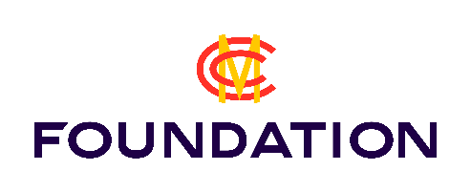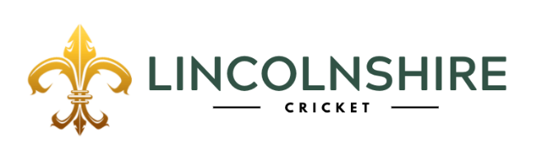

Lincolnshire County Cricket
Golf Day
Friday 18th October 2024 – Blankney Golf Club

Team Members | Handicap | Contact details  (Address, tel, email for Captain)
(Captain)
Options |  | Please indicate quantity
Team (£200)
Individual (£50)
Hole sponsorship (£75)
Putting Green sponsorship (£125)
Practice Ground sponsorship (£125)
Total |  | £

Please make payment by BACS to: Lincolnshire County Cricket Ltd. Account details: Lloyds Bank, Sort Code: 30 67 76, Account No: 291 959 60, using your Captain’s name as a reference.

Cheques can be made payable to Lincolnshire County Cricket Ltd, but must be delivered to Lincolnshire Cricket, c/o Ruston’s Sports and Social Club, Newark Road, Lincoln LN6 8RN

Booking and payment must be received by cga@lincscricket.co.uk prior to Wednesday 16th October in order to secure your place.

All profits from the event will go to supporting the delivery of MCC Foundation Hubs in Lincolnshire.

Queries to Martyn Dobson: martyn.dobson@lincscricket.co.uk Tel: 07543 221 292, or Clare Gilman-Abel: cga@lincscricket.co.uk Tel: 07543 221 294

