

Sobraon Barracks, Burton Road Cricket Ground
Facility Development Plan
Lincolnshire Cricket Ltd

October 2024

Contents:
- Background and Context
  - History
  - Current situation
- Delivering Impact
  - Concept
  - Need
  - Priority areas
- Bringing the Barracks ground back to life
  - Phase 1.
  - Phase 2.
  - Phase 3.
- Projected annual usage
- A home for Lincolnshire Cricket
  - Pitch and outfield
- Use of Pavilion and Car Park
  - Pavilion
  - Car Park
- Consultation
  - Approach
  - Feedback
  - Long term commitment

- Background & Context:
1.1 History:
The Sobraon Barracks Cricket Field is an area at the side of the Territorial Army barracks that has been used to stage cricket matches for over 70 years. Originally the site was home to the now defunct South Cliff Cricket Club and had on it a small wooden pavilion, which was eventually destroyed by fire.
In the summer of 2012, the City of Lincoln approved the development of the site which included ground works to the cricket square and outfield along with the build of a new pavilion in the south-west corner of the field.
It was agreed that the University of Lincoln would hold a 25-year lease and assume responsibility for the day-to-day management and maintenance of the site. It was envisioned that the cricket ground would become a permanent home to university cricket teams in addition to accommodating local recreational cricket and County Age Group Cricket.
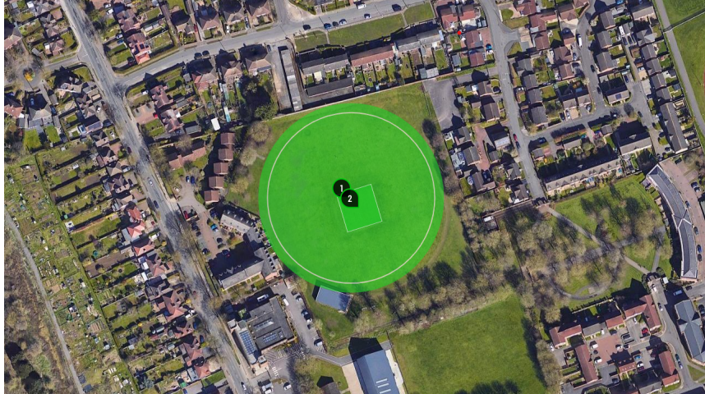

A new pavilion was built and opened in 2013 using funding secured from the City Council, the University of Lincoln and the ECB.
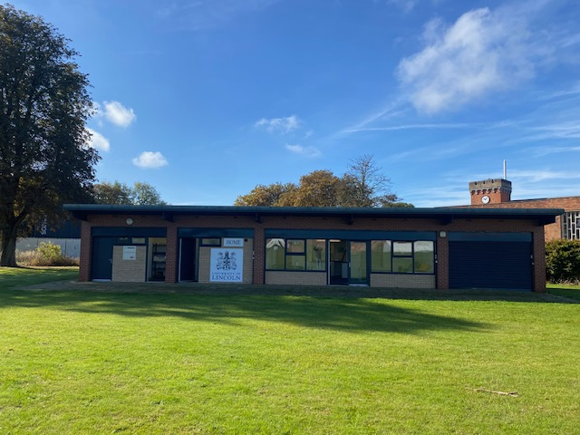

Over the period 2012 – current day, the cricket facilities at Sobraon Barracks have gradually deteriorated, resulting in less cricket being played on site year on year due to the standard of playing surfaces gradually deteriorating. In the early stages of this period, university cricket, recreational cricket and county age group cricket regularly took place on site. Over the past 2 summers however (2023, 2024) there has been no cricket played on site and it has become evident that the University of Lincoln do not have access to the necessary expertise or resource to adequately maintain the playing facilities.

1.2 Current situation:
Due to commercial pressures and a lack of income generated via the external hire of the cricket ground, the decision was taken by the University to sell all grounds maintenance equipment on site and effectively ‘mothball’ the site and pavilion, undertaking only basic maintenance of both.
At present the cricket facilities (outfield and square) are unfit to accommodate cricket. Whilst the pavilion has excellent facilities (changing rooms, kitchen, communal area etc) the site is unused, dormant and with no plans for any future usage by the University or any other team.
Through discussion between the University of Lincoln and Lincolnshire Cricket Ltd, the concept of transferring the ownership of the lease (with extension) from the University of Lincoln to the National Governing Body for cricket in the county (Lincolnshire Cricket Ltd) was explored. These discussions led to a joint approach being made to the City Council to consider a change in approach with regards to the future usage and management of the site.
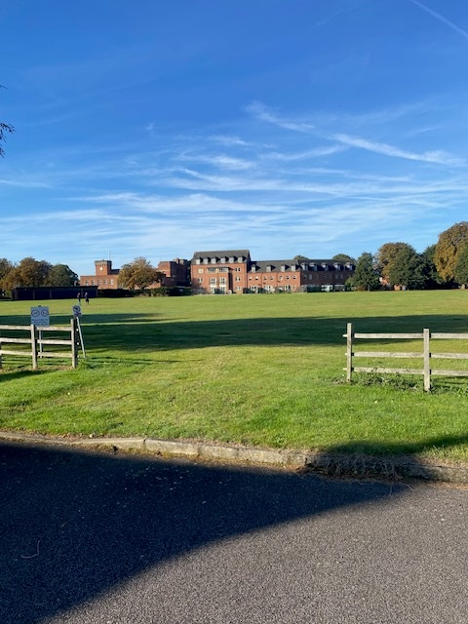
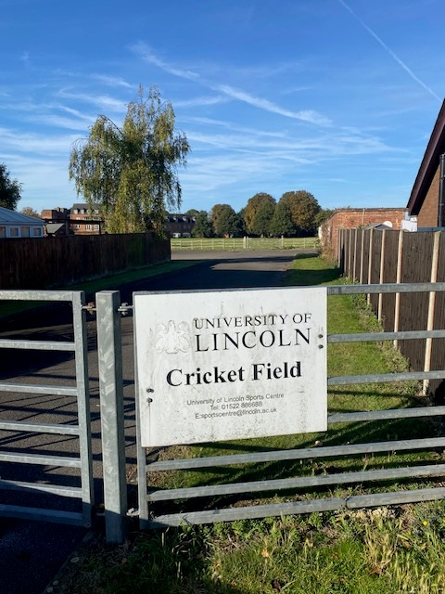

- Delivering Impact:

2.1 Concept:
This facility development plan centres around a transfer and extension of the current lease (min 25 years) from the University of Lincoln to Lincolnshire Cricket Ltd. This change in approach would create opportunities for Lincolnshire Cricket Ltd to leverage strategic facilities funding via the ECB (England & Wales Cricket Board) and create a sustainable business plan that enables the continued development and maintenance of the site, delivering a high quality, centrally located cricket facility that has the capacity to deliver significant impact across a number of areas.

2.2 Need:
As highlighted in Lincolnshire Cricket’s Facilities Strategy (2023-2032), there is clear need to develop a centrally located performance hub within the Lincolnshire to ensure the performance pathway is accessible to those living within our county. Currently, all county representative cricket and participation activity delivered by Lincolnshire Cricket is staged at recreational cricket clubs and school sites within Lincoln and Lincolnshire, placing increased pressure on existing facilities already struggling to meet demand. Between 2019 and 2022, participation in cricket in Lincolnshire has grown, fixtures completed in the recreational game have increased from 604 – 640 whilst participants have increased from 1225 to 1345 in addition to 1800, 5–11 year-olds now taking part in national, introductory programmes at clubs (All Stars Cricket & Dynamo Cricket).

2.3 Priority areas:
The future usage of the Sobraon Barracks Cricket Ground would be prioritised around:
- Women and Girls Cricket:
The Sobraon Barracks Ground would become home to the Lincolnshire Women’s and Girl’s performance programme, providing a venue for practice sessions and games for the 3 County age Group girls representative teams (U13/15 & 18). In addition, the site would be the recognised home of the Lincolnshire senior women’s county team, who from 2025 will be competing in Tier 3 of the national domestic women’s cricket competition.
Currently, representative practice sessions and games take place on existing recreational cricket grounds, placing increased stress on a network of facilities already struggling to accommodate demand. Over the last 5 years Lincolnshire has gone from 5 – 27 women’s sections and in the girl’s environment, from 0 – 10 sections. Within the county there are only 2 clubs (of 80) who have dual pitch sites and the growth in female cricket is resulting in significant pressure being placed on existing facilities, with many clubs finding access at peak times a significant challenge. Relocating a significant number of county representative fixtures would free up space within the recreational network, easing pressure and enabling clubs to service the uplift in demand experienced over recent years.
In addition to becoming a performance centre for women and girls’ cricket, the Barracks ground would also host a number of recreational women and girl’s activities/initiatives including:
- Women’s softball activity – becoming the recognised home for the Lincolnshire Women’s Softball League (established in 2024)
- Centrally located Girl’s softball festivals
- Female coach education programmes

- Community Activity:
The Barracks ground would become home to several centrally located community initiatives focused on participation and growth. Such activity would be focused on reaching new audiences via introductory activity using national and other recognised programmes as the vehicle to engage predominantly young people. Such activity would feature:
- School holiday activity via All Stars Cricket (5-8 yr olds) & Dynamos Cricket (8-11 yr olds) delivered in Easter and Summer school holidays.
- Home to a Lincoln disability ‘Super 1’s’ programme
- Home to a Lincoln ‘Street’ project engaging young people from the local area not currently engaged in ‘mainstream’ cricket provision
In addition, the pavilion space would be used as a base from which to deliver a variety of training opportunities that will benefit the volunteer network within the county. Such activity would include:
- Safeguarding training
- Coach education
- Umpire/scoring courses
- Club consultation/engagement events

- Boys County Age Group Programme:
The ability to accommodate a number of county age group boy’s fixtures, in particular amongst the younger age groups (U13/U15), would further reduce the pressure on the recreational network to stage county representative fixtures. Whilst staging women and girls’ cricket would be the priority there will be capacity to stage an amount of boys’ county representative cricket on the site.

- A home for Lincolnshire Cricket Ltd:
The intention would be for the Lincolnshire Cricket workforce to relocate to the site and create a hybrid working space for its team of officers.

- Bringing the Barracks Ground Back To Life – A Phased Approach

This development plan features a phased approach to rejuvenating and reinstating the Sobraon Barracks cricket ground in a sustainable manner.
Phase 1 – Cricket (Outfield, square, ancillary facilities)
Phase 2 – Practice facilities
Phase 3 – Pavilion
Phases 2 & 3 represent opportunities to add value to the project through further enhancing the facilities on site. They are not essential to the completion of the project and would be realised at a time when Lincolnshire Cricket Ltd were in a financial position that supports its delivery and completion .

3.1 Phase 1 – Cricket:
Phase 1 is built around the principle of delivering a high-quality cricket facility capable of staging junior and Women’s county representative cricket. The dimensions of the playing area allow for boundary sizes beyond the minimum recommended distances ensuring that this site is suitable for this type of activity and poses minimal risk to neighbouring properties.
Phase 1:
- Outfield renovation
- Renovation of cricket square
- Purchase of machinery required to maintain site
- Purchase of roll on/off covers
- Installation of scoreboard
- Installation of NTP on square (non turf pitch)
- Installation of 1 x Hybrid cricket wicket
- Early maintenance handover programme
- Roll out net cage

3.2 Phase 2 – Practice facilities:
- Installation of twin net bay practice area
- Approx cost 40K
- Timing within 3 years
Funding to complete phase 2 would need to be sourced by Lincolnshire Cricket Ltd through applications to funders and/or any surplus generated by the organisation.

3.3 Phase 3 – Pavilion:
- Any modifications that may be needed to the building (additional changing rooms, office annex etc)
- Approx cost and timeframe – unknown
Funding to complete phase 3 would need to be sourced by Lincolnshire Cricket Ltd.

- Projected Annual Usage
Having conducted a recent site visit we predict the cricket square being an 8/9 wicket square with the addition of a non turf pitch. The priority for usage would be as stated in the ‘Priority areas’ section of this document and the below provides a realistic estimate of what an annual programme of usage could look like:
(note – ‘Practice’ includes all non-match play activity and would take place on the outfield or using the NTP. ‘Games’ indicate occasions when matches would take place using grass pitches)

Participant group | Activity type | Per annum | When (April – Oct) | No. of unique participants
Girls U13 | Practice/match days | 3 x practice  6 games | Midweek/Sundays | 80
Girls U15 | Practice/match days | 3 x practice  6 games | Midweek/Sundays | 80
Girls U18 | Practice/match days | 3 x practice  6 x games | Midweek/Sundays | 80
County Women | Practice/match days | 3 x practice  6 games | Midweek/Sundays | 80
Boys U13 | Practice/match days | 3 x practice  6 games | Midweek/Sundays | 80
Boys U14 | Practice/match days | 3 x practice  6 x games | Midweek/Sundays | 80
Boys U16 | Practice/match days | 3 x practice 6 x games | Midweek/Sundays | 80
MCC Foundation Hub (boys & girls) | Practice/match days | 12 practice  6 games | Midweek/Sundays | 36
Disability* | Practice | 22 x practice | Midweek | 12
Community usage** | Practice | 20 x practice | Midweek | 500
Other*** | Matches | 12 games | Saturdays | 150
Womens Softball | Matches | 8 matches (NTP) | Midweek/Sundays | 128
Total |  | 81 x practice  68 x matches |  | 1386
*Disability Super 1’s programme would provide a cohort of local young people (aged 12-25) with a disability providing the chance to play regular cricket. This programme will feature weekly practise sessions and occasional games. All activity would take place on the outfield/NTP and would follow the model of our flagship Super 1’s centre in Grimsby
**Community usage would be as outlined in the priority usage section
***’Other’ relates to the capacity to stage a small number of senior men’s recreational matches, as has previously been staged on this site prior to 2022. This would be prioritised around those clubs who do not have access to their own pitch. This could be on Saturdays or midweek as part of the Lincoln Midweek league. This would be a useful source of income in addition to further reducing the pressure within the network.

- A Home for Lincolnshire Cricket - Long Term Sustainability
Upon the completion of Phase 1, Lincolnshire Cricket Ltd would look to employ a cricket grounds person with the relevant skills, knowledge and expertise required to undertake the maintenance and upkeep of the cricket facilities.

5.1 Pitch and Outfield:
Winter (off season maintenance programme):
Duration | Hrs/week (average) | Duties
12 Weeks | 4 | General maintenance

Spring/Summer/Autumn maintenance programme:
Duration | Hrs/week (average) | Duties
40 Weeks | 16 | - 6/7 hours grass cutting  - 6/7 hours wicket preparation (rolling/watering/marking)  - 2/3 hours general maintenance

- Use of Pavilion & Car Park:
6.1 Pavilion:
Lincolnshire Cricket would look to relocate its business operations to the Pavilion on site, creating a hybrid working space in the communal area in the centre of the pavilion. Lincolnshire Cricket would look to utilise the building between normal office hours 2-3 days per week on a year-round basis.
In total, Lincolnshire Cricket employ 11 members of staff. 6 members of staff are regionally based meaning that under normal circumstances up to 5 employees would use the pavilion on 2-3 days across Mon – Fri.
Staff would enter the premises via the main gates and park any vehicles in the car park. Employees would be responsible for closing and locking the gate upon leaving the site.
Lincolnshire Cricket would assume full responsibility for maintaining the pavilion and all associated costs incurred.
Occasionally the pavilion would be used to host meetings and training events. Meetings held on site would feature local partners, stakeholders and others involved in the recreational game in Lincolnshire, in addition to Lincolnshire Cricket director meetings. Training events that would be delivered on site include:
- Safeguarding
- Mental Health first aid
- Umpire & scorer training
- Coach education
Many of the meetings and training events held on site would be delivered on weekday evenings, owing to the fact that most attendees will be volunteers. On such occasions, the number of attendees would not normally exceed 20 due to the capacity of the building, and all staff/visitors would park in the car park on site. Noise would be kept to a minimum and Lincolnshire Cricket Ltd would be responsible for closing and locking the gate.
Enabling the use of the building is critical to the facility development plan as the ability to offset current office rent and costs incurred through renting facilities would enable running costs of the facility to be met.

6.2 Use of Car Park
Lincolnshire Cricket Ltd would promote and make available the car park on site for all staff and visitors. During non-match days the circa 45 bay car park will provide ample space to meet demand.
On match days, again the car park will be promoted, and all visitors will be encouraged to use the space available. On the rare occasion that the car park becomes full, additional parking will be made available around the outfield with access through the car park.
At all times, all visitors will be communicated to, prior to arriving on site instructing them to park in the car park, accessible via the main entry gates.

- Consultation
7.1 Approach:
Lincolnshire Cricket Ltd would look to consult with residents, particularly those residents with properties on Aisne Close, Somme Close and Arnhem Close, all properties on Breedon Drive (both sides), all properties on Cambria Close, Sid Wilson Court and those sharing a boundary with the site on Burton Road (Breedon Drive down to Dunkirk Road).
Consultation will provide an opportunity to share the ambition for the development of the site and present the headline information included within this facility development plan.
Lincolnshire Cricket will provide opportunities for local residents to raise any concerns they may have about this project and share feedback so that this can be considered during the initial stages of this project.
Lincolnshire Cricket will look to do this by conducting a leaflet drop to residents which provides an overview of the development plan and the key information within this document. This will also include an invitation to attend an open evening in the Pavilion at which Lincolnshire Cricket CEO and Chair will deliver a presentation providing full details of the plan.

7.2 Feedback:
A key feature of the consultation will be around seeking feedback and allaying concerns. Residents will have the opportunity to provide feedback and ask questions, either in person through attendance at the open evening and/or in writing, in response to receiving the information leaflet. Following the open evening a working group at Lincolnshire Cricket and invited local city councillors will meet to review and consider feedback/questions raised during consultation and make amendments to the development plan if necessary.

7.3 Long term commitment
Lincolnshire Cricket Ltd are committed to working with the local residents to the site throughout the duration of occupancy and would look to establish a ‘local residents group’. This group would meet a minimum 2 times per year following the assignment of the lease. At this forum, concerns can be raised, discussed and managed on an ongoing basis. The City Council would also be invited to attend these twice-yearly meetings. This sub group would be included within the governance structure of Lincolnshire Cricket Ltd and reports would feed directly into the full board of directors of Lincolnshire Cricket Ltd.

